Systematic Biology
Editorial Office Annual Report
2016



Contents
Manuscript Submissions Received ………………………………………………………………… 1
By Manuscript Type ………………………………………………………………………………………..2
By country of Origin ………………………………………………………………………………………..3
Distribution of Original Manuscripts between Editors 2015 …..………………….……5
Decisions made on Original Manuscripts 2015 …..………………………………….……….7
Time from Submission to First Decision …………………………………………………..…….8
Final decisions and Acceptance rate to date …………………………………………….….. 9
Time from Submission to Final Decision ………………………………………………………..10

Manuscripts with Final Decision by Country of Origin……………………………………11

Manuscript Submissions Received

By Version
Number of Manuscripts
# of Manuscripts | 2012 |  |  | 2013 |  |  | 2014 |  |  | 2015 |  |  | 2016
# of Manuscripts | Orig | Rev | 2012 | Orig | Rev | 2013 | Orig | Rev | 2014 | Orig | Rev | 2015 | Orig | Rev | 2016
Jan | 25 | 19 | 44 | 21 | 10 | 31 | 22 | 6 | 28 | 19 | 11 | 30 | 21 | 19 | 40 | 173
Feb | 15 | 13 | 28 | 26 | 9 | 35 | 23 | 12 | 35 | 28 | 8 | 36 | 22 | 9 | 31 | 165
March | 19 | 13 | 32 | 30 | 7 | 37 | 25 | 14 | 39 | 25 | 12 | 37 | 19 | 24 | 43 | 188
April | 26 | 4 | 30 | 22 | 12 | 34 | 35 | 21 | 56 | 20 | 16 | 36 | 19 | 19 | 38 | 194
May | 19 | 11 | 30 | 24 | 12 | 36 | 23 | 14 | 37 | 18 | 14 | 32 | 22 | 13 | 35 | 170
June | 18 | 13 | 31 | 17 | 9 | 26 | 29 | 8 | 37 | 35 | 17 | 52 | 26 | 12 | 38 | 184
July | 23 | 17 | 40 | 27 | 16 | 43 | 20 | 16 | 36 | 20 | 14 | 34 | 13 | 10 | 23 | 176
August | 25 | 10 | 35 | 23 | 3 | 26 | 23 | 17 | 40 | 27 | 15 | 42 | 27 | 14 | 41 | 184
Sept | 17 | 4 | 21 | 20 | 6 | 26 | 23 | 12 | 35 | 25 | 15 | 40 | 10 | 10 | 20 | 142
Oct | 26 | 7 | 33 | 23 | 8 | 31 | 21 | 9 | 30 | 25 | 12 | 37 | 18 | 19 | 37 | 168
Nov | 18 | 9 | 27 | 16 | 20 | 36 | 31 | 22 | 53 | 29 | 14 | 43 | 18 | 13 | 31 | 190
Dec | 18 | 5 | 23 | 24 | 17 | 41 | 14 | 14 | 28 | 33 | 14 | 47 | 27 | 8 | 35 | 174
 | 249 | 125 | 374 | 273 | 129 | 402 | 289 | 165 | 454 | 304 | 162 | 466 | 242 | 170 | 412 | 2,108

By Manuscript Type
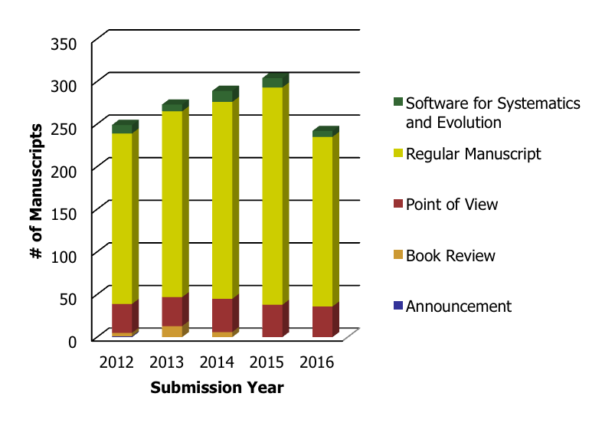
# of Manuscripts | 2012 | 2013 | 2014 | 2015 | 2016 | Summary
Announcement | 1 |  |  |  |  | 1
Book Review | 4 | 13 | 6 |  |  | 23
Point of View | 34 | 34 | 39 | 38 | 36 | 181
Regular Manuscript | 200 | 218 | 231 | 255 | 199 | 1,103
Software for Systematics and Evolution | 10 | 8 | 13 | 11 | 7 | 49
Summary | 249 | 273 | 289 | 304 | 242 | 1,357

By Country of Origin
# of Manuscripts | 2012 | 2013 | 2014 | 2015 | 2016 | Summary
Argentina | 1 | 1 | 7 | 4 | 2 | 15
Australia | 6 | 11 | 11 | 8 | 11 | 47
Austria | 1 | 2 | 3 | 6 | 5 | 17
Belgium | 1 | 2 | 3 | 6 | 3 | 15
Brazil | 4 | 1 | 7 | 9 | 6 | 27
Brunei Darussalam |  | 1 |  |  |  | 1
Canada | 5 | 16 | 8 | 10 | 10 | 49
Chile |  |  |  |  | 1 | 1
China | 17 | 18 | 16 | 31 | 28 | 110
Colombia |  |  | 1 |  | 1 | 2
Croatia |  | 1 |  | 1 |  | 2
Cyprus |  | 1 |  |  |  | 1
Czech Republic |  |  |  | 1 | 1 | 2
Denmark | 8 | 4 | 1 | 2 | 1 | 16
Egypt |  |  | 1 | 3 |  | 4
Estonia |  | 1 |  |  |  | 1
Finland | 5 | 1 | 2 | 4 | 1 | 13
France | 20 | 21 | 14 | 16 | 19 | 90
Germany | 14 | 14 | 20 | 20 | 10 | 78
Greece |  | 1 |  |  |  | 1
Hungary | 1 |  |  |  | 1 | 2
Iceland |  | 1 |  |  |  | 1
India | 4 | 1 | 6 | 4 | 5 | 20
Indonesia |  |  | 1 |  |  | 1
Iran, Islamic Republic of |  |  | 1 |  |  | 1
Ireland | 2 | 3 |  |  |  | 5
Israel | 3 | 3 | 1 | 2 | 1 | 10
Italy | 7 | 3 | 8 | 3 | 4 | 25
Japan |  | 2 | 4 | 2 | 1 | 9
Jordan |  |  | 1 |  |  | 1
Korea (the Republic of) |  |  |  | 3 | 1 | 4
Korea, Republic of | 1 | 1 |  |  |  | 2
Latvia |  | 1 |  |  |  | 1
Malaysia |  |  |  | 1 |  | 1
Mexico | 3 | 4 | 4 | 1 | 2 | 14
Netherlands | 1 | 1 | 2 | 3 |  | 7
New Zealand | 7 | 6 | 7 | 7 | 6 | 33
Norway |  |  | 3 | 3 | 1 | 7
Poland |  | 3 | 1 | 1 | 2 | 7
Portugal | 2 | 5 | 3 | 1 | 3 | 14
Puerto Rico |  | 1 |  | 2 |  | 3
Russian Federation | 2 |  | 1 | 1 | 1 | 5
Serbia |  |  |  | 1 |  | 1
Singapore |  | 1 | 3 | 1 | 1 | 6
Slovenia |  |  | 1 | 1 |  | 2
South Africa | 1 | 3 | 3 | 2 |  | 9
Spain | 9 | 7 | 7 | 7 | 6 | 36
Sweden | 7 | 17 | 8 | 7 | 6 | 45
Switzerland | 4 | 9 | 10 | 8 | 10 | 41
Taiwan | 1 |  |  |  |  | 1
Thailand | 1 |  |  |  |  | 1
Turkey | 1 | 1 | 1 |  |  | 3
Ukraine |  |  |  |  | 1 | 1
United Kingdom of Great Britain and Northern Ireland | 25 | 23 | 27 | 16 | 18 | 109
United States | 85 | 81 | 91 | 106 | 73 | 436
Viet Nam |  |  | 1 |  |  | 1
Summary | 249 | 273 | 289 | 304 | 242 | 1,357

Distribution of Original Manuscripts between Editors 2016
Editor Full Name | # of Manuscripts
Albert, James | 6
Alfaro, Michael | 3
Anderson, Frank (Andy) | 1
Antonelli, Alexandre | 3
Brumfield, Robb | 6
Bryant, David | 5
Buckley, Thomas | 3
Charleston, Michael | 5
Dayrat, Benoit | 3
Edwards, Erika | 5
Faith, Dan | 1
Fishbein, Mark | 5
Foster, Peter | 4
Friedman, Matt | 5
Gascuel, Olivier | 2
Glor, Richard | 2
Goldberg, Emma | 6
Hahn, Matthew | 3
Halanych, Ken | 3
Harmon, Luke | 6
Holder, Mark | 8
Jermiin, Lars | 2
Kjer, Karl | 1
Kubatko, Laura | 6
Leache, Adam | 3
MacLeod, Norm | 6
Mason-Gamer, Roberta | 2
McCormack, John | 5
Moore, Brian | 3
Near, Thomas | 9
Paterson, Adrian | 2
Posada, David | 4
Ree, Richard | 5
Renner, Susanne | 9
Savolainen, Vincent | 5
Serb, Jeanne | 2
Smith, Leo | 7
Stadler, Tanja | 6
Susko, Edward | 5
Townsend, Jeffrey | 2
Wiegmann, Brian | 5
Williams, Tiffani | 2
Summary | 176

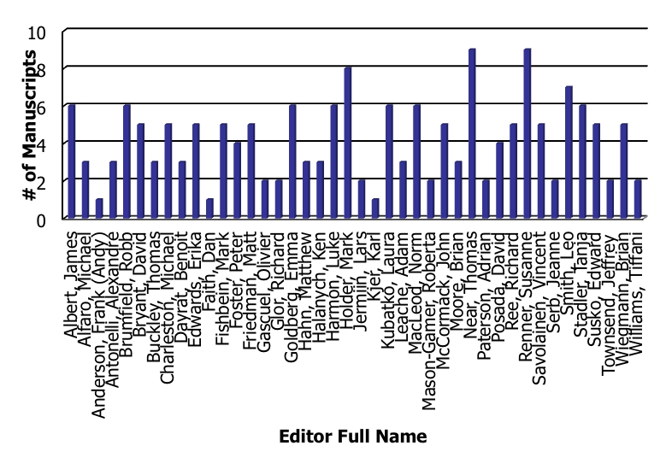

Decisions Made on Original Manuscripts 2016

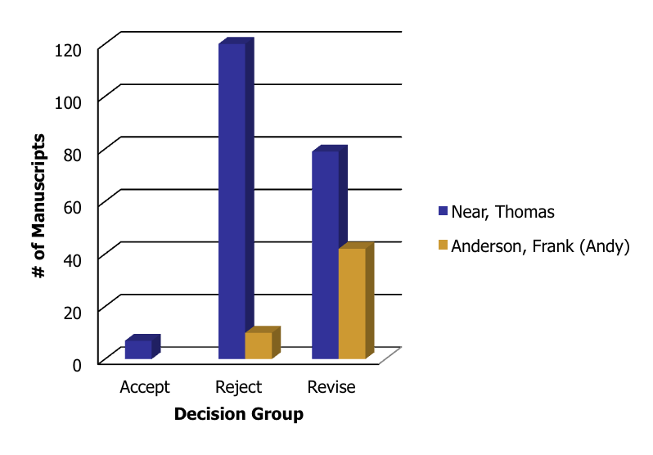
 | Accept |  |  | Reject |  |  | Revise
 | Accept | Accept pending receipt of final changes | Accept | Not appropriate for journal | Reject | Reject | Accept with major revisions | Accept with minor revision | Reject; resubmission encouraged | Revise
Near, Thomas | 1 | 6 | 7 | 82 | 38 | 120 | 31 | 23 | 25 | 79 | 206
Anderson, Frank (Andy) |  |  |  |  | 10 | 10 | 16 | 7 | 19 | 42 | 52
 | 1 | 6 | 7 | 82 | 48 | 130 | 47 | 30 | 44 | 121 | 258

Time from Submission to First Decision

Decision | # of Manuscripts | Average Days
Accept | 1 | 71.00
Accept pending receipt of final changes | 6 | 75.00
Accept with major revisions | 47 | 84.64
Accept with minor revision | 30 | 84.50
Not appropriate for journal | 82 | 8.21
Reject | 48 | 76.25
Reject; resubmission encouraged | 44 | 86.43
Summary | 258 | 58.80

Final Decisions and Acceptance Rate to date

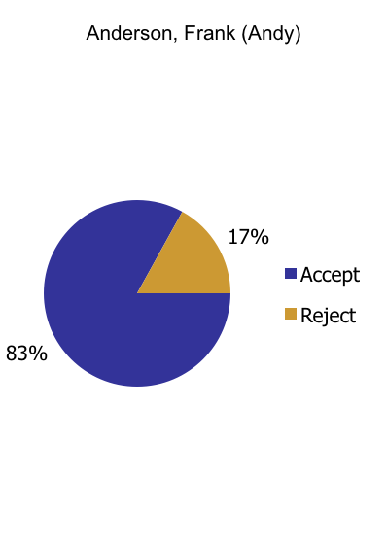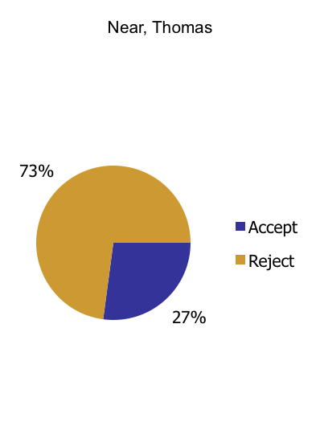

# of Manuscripts | Accept |  |  | Reject |  |  | Summary
# of Manuscripts | Accept | Accept pending receipt of final changes | Accept | Not appropriate for journal | Reject | Reject | Summary
Anderson, Frank (Andy) | 49 |  | 49 |  | 10 | 10 | 59
Near, Thomas | 42 | 3 | 45 | 82 | 39 | 121 | 166
Summary | 91 | 3 | 94 | 82 | 49 | 131 | 225

Acceptance Rate: 41.78%

Time from Submission to Final Decision

Final Decision | Decision | # of Manuscripts | Average Days
Accept | Accept | 91 | 273.13
Accept | Accept pending receipt of final changes | 3 | 383.33
Accept |  | 94 | 276.65
Reject | Not appropriate for journal | 82 | 8.21
Reject | Reject | 49 | 143.47
Reject |  | 131 | 58.80
Summary |  | 225 | 149.81

Manuscripts with Final Decision by Country of Origin

# of Manuscripts | 2012 |  |  | 2013 |  |  | 2014 |  |  | 2015 |  |  | 2016 |  |  | Summary
# of Manuscripts | Accept | Reject | 2012 | Accept | Reject | 2013 | Accept | Reject | 2014 | Accept | Reject | 2015 | Accept | Reject | 2016 | Summary
Argentina |  | 3 | 3 |  |  |  | 2 | 1 | 3 |  | 3 | 3 |  | 3 | 3 | 12
Australia | 5 | 3 | 8 | 4 | 1 | 5 | 5 | 5 | 10 | 4 | 3 | 7 | 4 | 6 | 10 | 40
Austria |  | 2 | 2 |  | 1 | 1 |  | 1 | 1 | 3 | 2 | 5 | 2 | 1 | 3 | 12
Belgium |  |  |  |  |  |  | 1 | 2 | 3 | 2 | 4 | 6 | 1 | 3 | 4 | 13
Brazil |  | 3 | 3 |  | 1 | 1 | 1 | 6 | 7 |  | 6 | 6 |  | 5 | 5 | 22
Brunei Darussalam |  |  |  |  | 1 | 1 |  |  |  |  |  |  |  |  |  | 1
Canada | 4 | 2 | 6 | 1 | 7 | 8 | 4 | 7 | 11 | 1 | 4 | 5 | 1 | 8 | 9 | 39
Chile |  |  |  |  |  |  |  |  |  |  |  |  |  | 1 | 1 | 1
China |  | 15 | 15 |  | 15 | 15 | 1 | 16 | 17 | 2 | 28 | 30 |  | 26 | 26 | 103
Colombia |  |  |  |  |  |  |  | 1 | 1 |  |  |  |  | 1 | 1 | 2
Croatia |  |  |  |  | 1 | 1 |  |  |  |  | 1 | 1 |  |  |  | 2
Cyprus |  |  |  |  | 1 | 1 |  |  |  |  |  |  |  |  |  | 1
Czech Republic |  |  |  |  |  |  |  |  |  |  |  |  |  | 1 | 1 | 1
Denmark | 3 | 2 | 5 | 1 | 1 | 2 | 1 | 1 | 2 |  | 1 | 1 | 1 | 1 | 2 | 12
Egypt |  |  |  |  |  |  |  | 1 | 1 |  | 3 | 3 |  |  |  | 4
Estonia |  |  |  |  | 1 | 1 |  |  |  |  |  |  |  |  |  | 1
Finland | 1 | 4 | 5 |  |  |  | 1 | 1 | 2 |  |  |  | 3 |  | 3 | 10
France | 5 | 10 | 15 | 9 | 10 | 19 | 4 | 6 | 10 | 3 | 7 | 10 | 6 | 9 | 15 | 69
Germany | 5 | 8 | 13 | 1 | 5 | 6 | 7 | 8 | 15 | 4 | 6 | 10 | 6 | 6 | 12 | 56
Greece |  |  |  |  | 1 | 1 |  |  |  |  |  |  |  |  |  | 1
Hungary |  | 1 | 1 |  |  |  |  |  |  |  |  |  |  |  |  | 1
Iceland |  |  |  |  | 1 | 1 |  |  |  |  |  |  |  |  |  | 1
India |  | 4 | 4 |  | 1 | 1 |  | 6 | 6 |  | 4 | 4 |  | 4 | 4 | 19
Indonesia |  |  |  |  |  |  |  | 1 | 1 |  |  |  |  |  |  | 1
Iran, Islamic Republic of |  |  |  |  |  |  |  | 1 | 1 |  |  |  |  |  |  | 1
Ireland | 1 | 1 | 2 | 1 |  | 1 | 1 |  | 1 |  |  |  |  |  |  | 4
Israel |  | 2 | 2 |  | 2 | 2 | 1 | 1 | 2 |  | 2 | 2 |  | 1 | 1 | 9
Italy | 1 | 4 | 5 | 1 | 2 | 3 | 1 | 4 | 5 | 1 |  | 1 | 2 | 3 | 5 | 19
Japan |  |  |  |  | 1 | 1 |  | 4 | 4 |  | 2 | 2 |  | 1 | 1 | 8
Jordan |  |  |  |  |  |  |  | 1 | 1 |  |  |  |  |  |  | 1
Korea (the Republic of) |  |  |  |  |  |  |  |  |  | 1 |  | 1 |  | 1 | 1 | 2
Korea, Republic of |  | 1 | 1 |  |  |  |  | 1 | 1 |  |  |  |  |  |  | 2
Latvia |  |  |  |  | 1 | 1 |  |  |  |  |  |  |  |  |  | 1
Malaysia |  |  |  |  |  |  |  |  |  |  | 1 | 1 |  |  |  | 1
Mexico |  | 2 | 2 | 1 | 4 | 5 |  | 4 | 4 |  |  |  | 1 | 1 | 2 | 13
Netherlands | 2 |  | 2 |  | 1 | 1 |  | 2 | 2 |  | 2 | 2 |  |  |  | 7
New Zealand | 2 | 1 | 3 | 2 | 1 | 3 | 3 | 2 | 5 | 4 | 1 | 5 | 2 | 3 | 5 | 21
Norway |  |  |  |  |  |  |  | 3 | 3 |  | 3 | 3 |  |  |  | 6
Poland |  |  |  |  | 3 | 3 |  | 1 | 1 |  | 1 | 1 |  | 2 | 2 | 7
Portugal |  | 1 | 1 | 1 | 2 | 3 | 1 | 1 | 2 | 1 |  | 1 | 1 | 2 | 3 | 10
Puerto Rico |  |  |  | 1 |  | 1 |  |  |  |  | 1 | 1 |  |  |  | 2
Russian Federation |  | 2 | 2 |  |  |  |  | 1 | 1 |  | 1 | 1 |  | 1 | 1 | 5
Serbia |  |  |  |  |  |  |  |  |  |  | 1 | 1 |  |  |  | 1
Singapore |  |  |  | 1 |  | 1 |  | 3 | 3 |  | 1 | 1 |  | 1 | 1 | 6
Slovenia |  |  |  |  |  |  |  | 1 | 1 |  |  |  |  | 1 | 1 | 2
South Africa |  | 1 | 1 | 1 |  | 1 | 1 |  | 1 | 2 | 1 | 3 |  |  |  | 6
Spain | 2 | 4 | 6 | 1 | 4 | 5 | 2 | 3 | 5 | 3 | 3 | 6 | 2 | 3 | 5 | 27
Sweden | 5 | 2 | 7 | 9 | 3 | 12 | 6 | 3 | 9 | 5 | 1 | 6 | 4 |  | 4 | 38
Switzerland | 3 | 2 | 5 | 1 | 2 | 3 | 3 | 2 | 5 | 4 |  | 4 | 7 | 3 | 10 | 27
Taiwan |  | 1 | 1 |  |  |  |  |  |  |  |  |  |  |  |  | 1
Thailand |  | 1 | 1 |  |  |  |  |  |  |  |  |  |  |  |  | 1
Turkey |  | 1 | 1 |  | 1 | 1 |  | 1 | 1 |  |  |  |  |  |  | 3
Ukraine |  |  |  |  |  |  |  |  |  |  |  |  |  | 1 | 1 | 1
United Kingdom of Great Britain and Northern Ireland | 2 | 9 | 11 | 9 | 7 | 16 | 16 | 7 | 23 | 6 | 4 | 10 | 7 | 7 | 14 | 74
United States | 23 | 34 | 57 | 32 | 19 | 51 | 32 | 31 | 63 | 31 | 32 | 63 | 44 | 25 | 69 | 303
Viet Nam |  |  |  |  |  |  |  | 1 | 1 |  |  |  |  |  |  | 1
Summary | 64 | 126 | 190 | 77 | 101 | 178 | 94 | 141 | 235 | 77 | 129 | 206 | 94 | 131 | 225 | 1,034

